04/01/20

**THM 121 Business Mathematics**

**Final Exam Answer Sheet**

**Note to the students**:

* Calculations to reach your answers shall be thoroughly shown. Otherwise, questions will NOT be graded.
* You can use a calculator throughout the exam.

1. Consider the following equation of a line: [(χ + 3) / (-5)] + [(y – 1) / 2] = 1
2. Find the **slope** and the **intercepts** of the line. (**3** Points)

[(χ + 3) / (-5)] + [(y – 1) / 2] = 1 ↔ [(2χ + 6) / (-10)] + [(-5y + 5) / (-10)] = 1 ↔ 2χ + 6 + (-5y + 5) = -10 ↔ 2χ + 6 - 5y + 5 + 10 = 0 ↔ 2χ + 21 = 5y ↔ y = (2/5) χ + (21/5).

Therefore, the slope of the line is **2/5**. In order to find the intercepts:

χ intercept: set y = 0 and solve for χ → χ intercept is **(-21/2, 0)**.

y intercept: set χ = 0 and solve for y → y intercept is **(0, 21/5)**.

1. Sketch the graph of the line. (**2** Points)

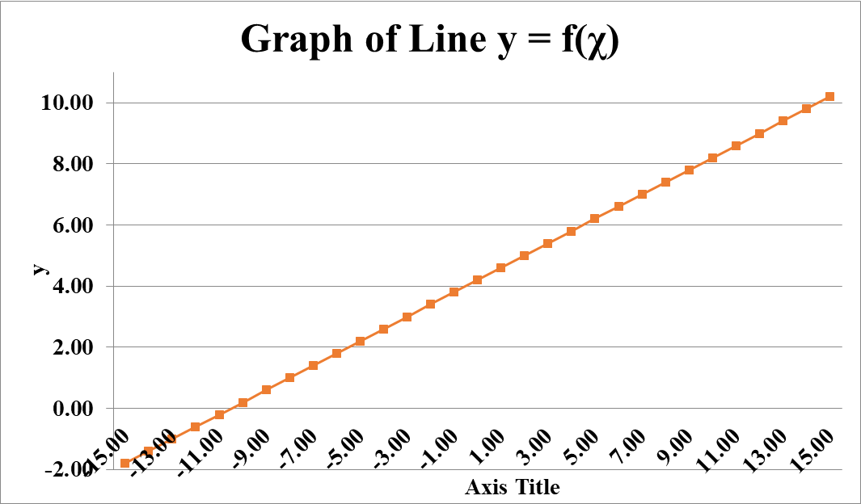

1. For tax purposes, the book value of certain assets is determined by depreciating the original value of the asset **linearly** over a fixed period of time. Suppose an asset, originally worth ***V*** dollars, is linearly depreciated over a period of ***N*** years, at the end of which it has a scrap (salvage) value of ***S*** dollars.
2. Express the book value ***B*** of the asset ***t*** years into the ***N***-year depreciation period as a linear function of ***t***. [Hint: Note that ***B*** = ***V*** when ***t*** = **0** and ***B*** = ***S*** when ***t*** = ***N***.] (**4** Points)

Using the points (0, *V*) and (*N*, *S*), the slope of the line is (*S* – *V*) / *N*. Therefore, the value of an asset after *t* years is:

**B (t) = [(*S* – *V*) / *N*] *t* + *V***

1. Suppose a $ 50,000 piece of office equipment is depreciated linearly over a 5-year period, with a scrap (salvage) value of $ 18,000. What is the **book value** of the equipment **after 3 years**? (**2** Points)

For this very office equipment: B (t) = [(18,000 – 50,000) / 5] * 3 + 50,000 = (-6,400 * 3) + 50,000 = -19,200 + 50,000 = 30,800. Therefore the value of this office equipment after 3 years is **$ 30,800**.

3) Students at a state college may preregister for their fall classes by mail during the summer. Those who do not preregister must register in person in September. The registrar can process **35** students per hour during the September registration period. Suppose that after 4 hours in September, a total of **360** students (including those who preregistered) have been registered.

a) Express the number of students registered as a function of time and draw the graph. (**4** Points)

Let χ be the number of hours spent registering students in person. During the first 4 hours, 4 * 35 = **140** students were registered. So, 360 – 140 = **220** students had preregistered. Let y be the total number of students who register. Then, **y = 35 χ + 220**.

b) How many students were registered after 3 hours? (**2** points)

y = (3 * 35) + 220 = 325. Therefore, after 3 hours, **325** students were registered.

1. How many students preregistered during the summer? (**2** Points)

From part (a), we can see that **220** students had preregistered.

1. Julia can sell a ceratin product for $ 110 per unit. Total cost consists of a fixed overhead of $ 7,500 and production costs of $ 60 per unit.
2. Express Julia’s **total revenue**, **total cost**, and **total profit** in terms of **χ**, the number of units sold. Sketch the *total revenue* and *total cost* functions on the same set of axes. (**5** Points)

Total revenue = (Selling price) (# Units sold). Let ***R*** represent the total revenue and χ represent the number of units sold. Then**, *R* (χ) = 110 χ**.

Total cost = Fixed overhead + (Cost per unit) * (# of Units produced). Let **C** represent the total cost. The, ***C* (χ) = 7500 + 60 χ**.

Total profit = Total Revenue – Total Cost = ***P* (χ)** = *R* (χ) – *C* (χ) = 110 χ – (60χ + 7500) = **50 χ - 7500**.

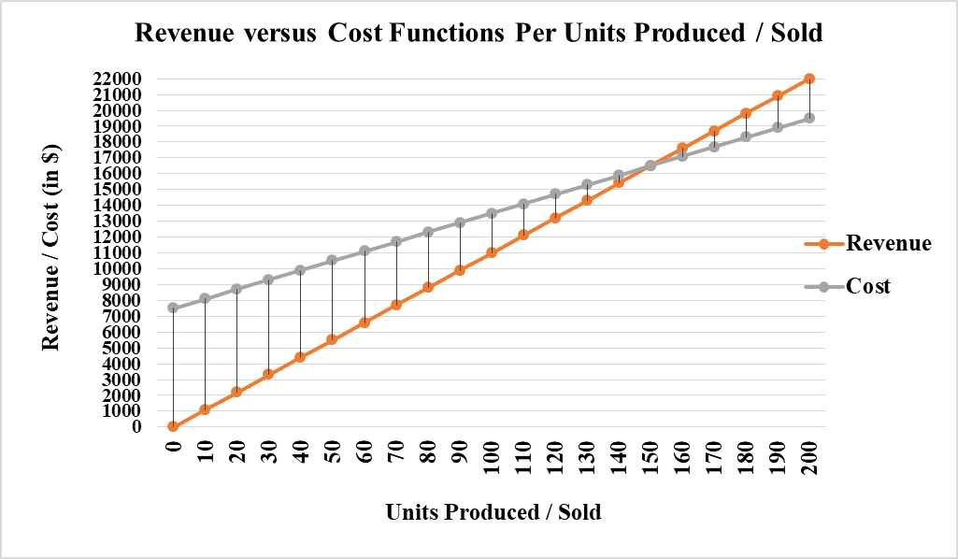

1. How many units must be sold for Julia to break even? (**2** Points)

To break even, we have to solve for χ that makes *P* (χ) = 0 ↔ *R* (χ) = *C* (χ) ↔ 110 χ = 60 χ + 7500 ↔ 50 χ = 7500 ↔ χ = 150. Therefore, when **150 units** are sold, Julia would break even.

1. What is Julia’s profit **or** loss if *100 units are sold*? (**2** Points)

*P* (100) = (50 * 100) – 7500 = 5000 – 7500 = - 2500. Therefore, when 100 units are sold, Julia will incur a **loss** of **$ 2,500**.

1. How many **units** must be sold for Julia to realize a **profit of $ 1,250**? (**1** Point)

*P* (χ) = 1250 ↔ 50 χ - 7500 = 1250 ↔ 50 χ = 8750 ↔ χ = 175. Therefore, for Julia to realize $ 1,250 of profits, **175 units** shall be sold.

1. Two species coexist in the same ecosystem. Species I has population ***P (t)*** in *t* years, while species II has population ***Q (t)***, both in thousands, where *P* and *Q* are modeled by the functions:

***P (t)* = 30 / (3 + *t*)** and ***Q (t)* = 64 / (4 – *t*)**

for all times t ≥ 0 for which the perspective populations are nonnegative.

1. What is the initial population of each specy? (**1** Point)

*P* (0) = 30 / (3 + 0) = 10 → P specie had initially a population of **10,000**.

*Q* (0) = 64 / (4 – 0) = 16 → Q specie had initially a population of **16,000**.

1. What happens to ***P (t)*** as *t* increases? What happens to ***Q (t)*** as *t* increases? (**2** Points)

Since *P* function is defined for all *t* ≥ 0, the function values decrease as *t* increases. Consequently,

 So, in the long run, ***P* tends to zero**.

On the other hand, *Q* function, however, only accepts values of *t* such that 0 ≤ *t* ≤ 4. This function increases as t increases. Consequently,. So, ***Q* increases without bound**.

1. Sketch the **graphs** of *P (t)* and *Q (t)* on the same set of axes. (**3** Points)

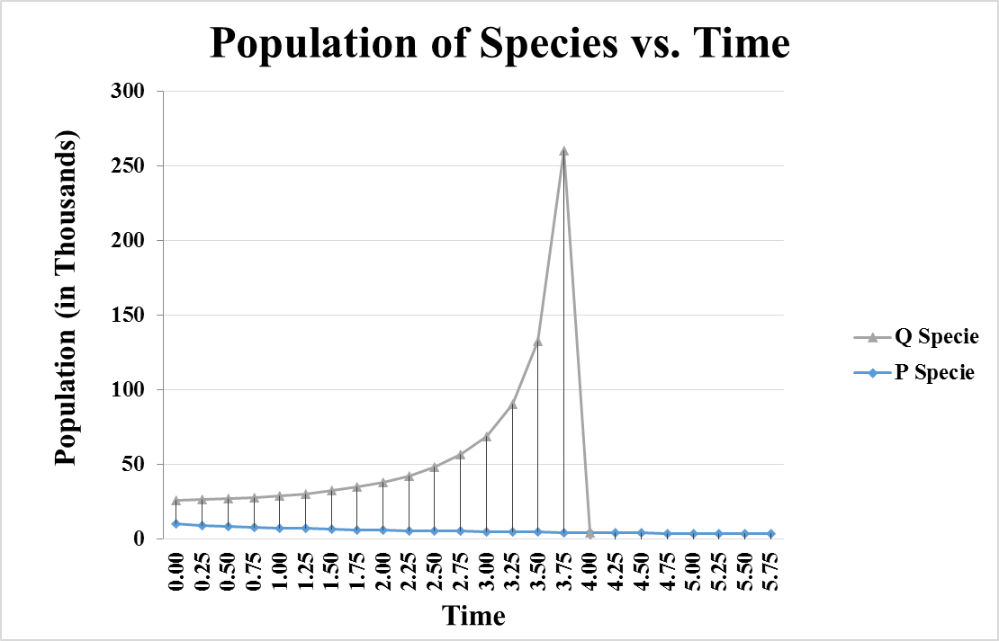

1. In 2010, the cost *p (χ)* in cents of mailing a letter weighting χ grams was:

$$p(x)=\left\{\begin{aligned}44 if &0<x≤1 \\ 61 if 1<x≤2 \\ 78 if &2<x≤3.50\end{aligned}\right.$$

Sketch the graph of *p (χ)* for 0 < χ ≤ 3.50 with increments of 0.25 grams. For what values of χ is *p (χ)* continuous on the domain ]0 , 3.50]? (**5** Points)

The graph will consist of horizontal line segments, with the left endpoints open and the right endpoints closed (from the inequalities). The height of each segment corresponds to the respective costs of postage.

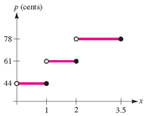

The function *P* is discontinuous on the domain ]0 , 3.50] only where the price jumps or when χ = 1 and when χ = 2.

**N.B**. Round your answers to the **nearest cent** for questions 2, 3, 4, 5 & 6.

**GOOD LUCK!**